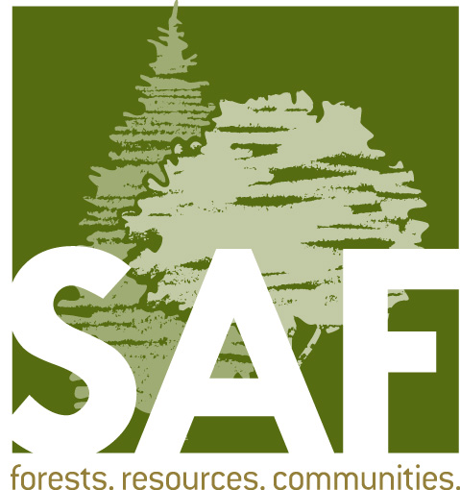

Fellow Nominations

Biographical and

Professional Information
(as of 2/7/24)

Name of Nominee:

Date:

Please complete and return this form to the Nominator for inclusion in the submitted Fellows packet.

List information in chronological order, starting with the most recent.

I. Information in support of the criteria – demonstrating a strong continuing commitment through direct SAF volunteer activities.

1. Year joined SAF:

2. Current Professional Position:
Title:
Employer:
City, State:
If retired, please state year retired:

3. Previous Work Experience:
List titles, employers, locations, and dates of employment.

4. Education and Professional Development:
List degrees with field, college or university, year graduated.
List any certification, licensing, or registration
List attendance at national conventions or leadership academies

5. Military service (if applicable):

6. SAF Activities and Accomplishments:
List and describe your SAF activities, accomplishments, awards and recognition by SAF level below which respond to the SAF criteria for Fellow. Within each SAF level, list information in chronological order, starting with the most recent.

National level (national level offices, committees, governing bodies, task forces, working groups, etc.):

State or multi-state level (state and regional offices, committees, etc.):

Chapter level (chapter and local level offices, activities, etc.):

II. Information in support of the criteria – exemplary action, sustained leadership, and advancement of the forestry profession in at least one of the following areas:

Application of forestry,
Education,
Public policy,
Research, or
Technology transfer

List and describe in chronological order your forestry professional activities, accomplishments, awards and recognition, which respond to the forestry profession criteria for Fellow.

III. Other Relevant Activities:

List any memberships and affiliations in other professional associations and organizations, including honorary and academic societies. List any community activities, including membership in civic organizations. List any awards (SAF or other) and recognitions.

